Use Case Document
Digital Banking – Money Movement – Wire Transfer

Version: DRAFT 1.00
Date Last Published: June 22, 2020
Date Signed: Click here to enter a date.
Use Case Document Author(s):
Neil Cory

Contents
Document Information 3
Revision History 3
Related Document References 3
Use Case Wire UC001 – Beneficiary Management 4
Business Requirements 6
Appendix A - Wires Information Requirements 6
Appendix B – Beneficiary Management Screen Captures 8
Use Case Wire UC002 – Initiate and Send Payment 10
Business Requirements 12
Appendix - Wires Screen Captures 14
Signature 17

Document Information

Revision History
Include signatures as part of the history
Version | Date | Authors | Revision Notes
1.00 | June 22, 2020 | Neil Cory | Initial draft

Related Document References
[List all relevant documents, such as: business case, existing business and IT Architecture models, roadmaps, document and model templates, standards, glossaries, etc. Include the version number, if appropriate.]
Ref | Document Name | Short Description and URL
1.0

Use Case Wire UC001 – Beneficiary Management
Use Case ID: | Wire Transfer UC001 – Beneficiary Management
Use Case Name: | Beneficiary Management
Created By: | Neil Cory | Last Updated By: | Neil Cory
Date Created: | June 22, 2020 | Date Last Updated: | June 22, 2020
Use Case Description: | An authorized user must create a net new beneficiary record. The user adds the beneficiary’s details and banking information. This information can then be used when creating a payment record.
Actors: | Authorized user for Beneficiary Management (s), Infinity Wires Beneficiary Management Module
Pre-Conditions: | - User is approved to create a Beneficiary.  - User is logged into Infinity and has navigated to the Wire Transfer Module.  - The user has beneficiary details to create the profile.
Post-Conditions: | - Transfer is successfully processed by wires service provider with confirmation email sent to initiator and beneficiary.  - The transfer failed processing by the service provider. The initiator receives an alert.  - The transfer was declined by an authorizing user.
Basic Flow: | - The creates a blank beneficiary profile  - The user adds the following details to the profile:  - The Beneficiary Name is the name that appears on the transaction. It should be the full legal name of the bank account holder.  - The Familiar Name field is populated with the beneficiary's name. You can change this value manually by typing in the field. The Familiar Name is a 'nickname' that can be used to refer to the beneficiary within CWB Wire Service.  - Bank Country of the beneficiary's bank.  - The Currency (is auto-populated with the standard currency for the selected Bank Country.)  - Delivery Method: This is how the payment will be delivered to the beneficiary. For CWB clients, it is Wire.  - Default Delivery Method: Reflects the delivery method.  - For further credit: Use this to enter further credit information.  - The Profile Id is a unique formal identifier for the beneficiary that may be used within your own systems or applications  - The Beneficiary Address is added to the profile:  - Street address  - City  - Postal Code  - Country  - Phone Number  - Notification Email Address  - Language  - The user searches for the beneficiary banking information to add it to the profile. The user can search by:  - Bank name and address  - Bank Swift Code  - BSB Number  - The user adds the beneficiary’s Bank Account Details to the Profile. These must include:  - Bank name,  - Bank address (street, city, country, postal code)  - Swift Code  - Add payment purpose details (Payment Type an Payment Purpose)  - Save the profile  End Basic Flow
Alternate | 5.a The bank details cannot be found. The user adds the details manually. These must include:  - Bank name,  - Bank address (street, city, country, postal code)  - Swift Code, or Fedwire Routing Code, or ACH Routing Code  5.b Add Correspondent Banking Details if required
Exception:
Use Case Priority: | High Priority
Frequency of Use: | Variable.
Business Rules: | A beneficiary must be added before a payment.
Functional Requirement:
Assumptions: | Wire service provide is agnostic.
Issues and Considerations:

Business Requirements
Requirement ID | Description
BR-Wires-1.00 | Ability to create International recipient profile
BR-Wires-1.01 | Ability to create Domestic recipient profile
BR-Wires-1.02 | Ability to add banking information to recipient profile
BR-Wires-1.03 | Ability to choose which currency international recipient will receive transfer in.
BR-Wires-1.04 | Ability to modify the details of a recipient.
BR-Wires-1.05 | Ability to delete a recipient
BR-Wires-1.06 | Must be able to add additional beneficiary notification email addresses to a beneficiary profile
BR-Wires-1.07 | Must be able to search for beneficiary bank account details when adding to a beneficiary

Appendix A - Wires Information Requirements
Field Category | Field Name
Info about Transfer | Domestic Transfer Code (ACE1)
 | International Transfer Code (ACE2)
 | Currency Type
 | Amount
 | US rate
 | CDN Equivalent
 | Reason
Fees | Currency Type
 | Amount
 | US rate
 | CDN Equivalent
 | Reason
Total of fees and wire amount | TOTAL
Total of fees and wire amount | Wires Amount in Words
Ordering Customer Info | Ordering Customer Name
 | ACCOUNT NUMBER
 | FULL ADDRESS (Must be resides at address - not a PO Box number
 | City
 | Province
 | Postal Code
Beneficiary Bank Info | Beneficiary Bank Name
 | Street Address
 | City
 | Province/State
 | Postal/Zip
 | Country
 | ABA/ROUTING/SWIFT CODE (if address note provided)
 | Bank#
 | Transit#
 | Account#
 | IBAN NUMBER
 | CLABE NUMBER
Branch to Branch Instructions | BENEFICIARY NAME
 | BENEFICIARY Full Address
 | City
 | Province/State
 | Postal/Zip
 | Country
Reason Details | Reason for Wire
 | Supplementary Information (supporting evidence)
Third Party Determination | Name of the Third Party
 | Street Address of the Third Party
 | City
 | Province
 | Postal Code
 | Country
 | Occupation/Nature of Business of Third Party
 | Nature of Your Relationship to Third Party
 | Date of Birth

Appendix B – Beneficiary Management Screen Captures
- Add Beneficiary Details
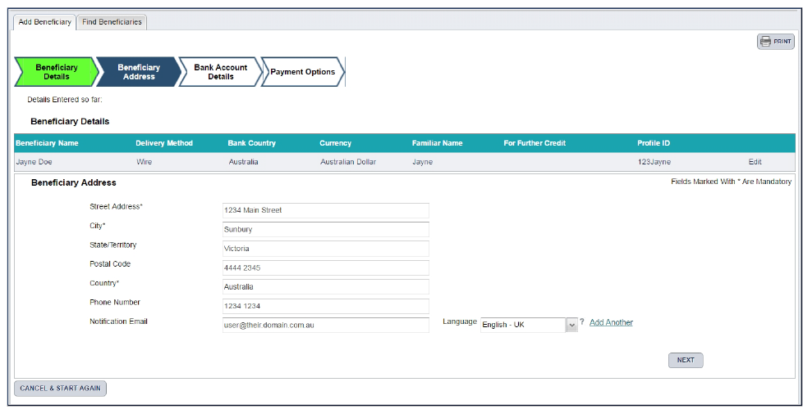
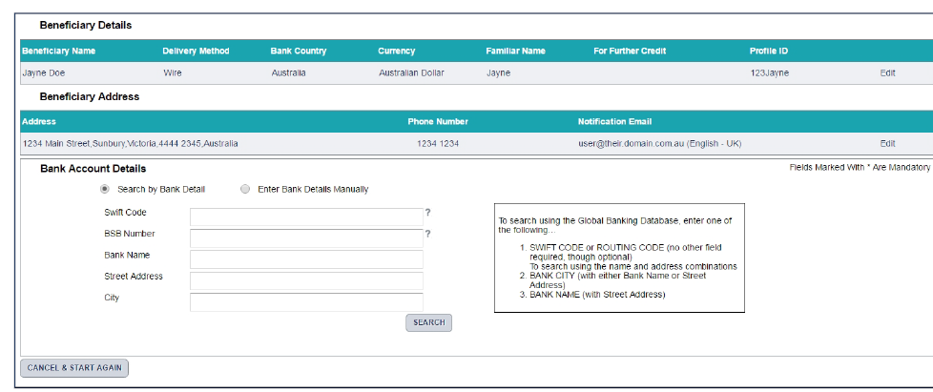

Use Case Wire UC002 – Initiate and Send Payment
Use Case ID: | Wire Transfer UC002 – Initiate and Send Payment
Use Case Name: | Wire Transfer - Initiate and Send Payment
Created By: | Neil Cory | Last Updated By: | Neil Cory
Date Created: | June 22, 2020 | Date Last Updated: | June 22, 2020
Use Case Description: | The wire initiating user must send a wire transfer to a beneficiary. This use case describe a basic flow where the user creates a new payment, searches for and selects a beneficiary, and adds the settlement account and payment details. Alternate flows describe options for initiating a payment though a template, initiating a quick payment, and secondary approval steps.
Actors: | The initiating user, payment beneficiaries, authorizing user, Infinity Wires Module, Third Party Wire Service.
Pre-Conditions: | - Currency type and amount to send in that currency need to be available  - The beneficiary (recipient entity who the money is being sent to) information must be in the system  - User is approved to create a wire payment.  - User is logged into Infinity and has navigated to the Wire Transfer Module
Post-Conditions: | - Transfer is successfully processed by wires service provider with confirmation email sent to initiator and beneficiary.  - The transfer failed processing by the service provider. The initiator receives an alert.  - The transfer was declined by an authorizing user.
Basic Flow: | - User selects “create new payment” to make a wire transfer  - User searches for and selects the beneficiary entity who will receive the money. ( when creating a new payment a selected beneficiary should have the information autocomplete)  - User selects the account the payment will be settled from (this is configured to the customer accounts that the customer chooses to settle from)  - User enters the amount to be paid to the beneficiary in the currency of the settlement account  - User enters the payment purpose details. This includes payment type, payment purpose, Client Payment ID)  - User adds the payment details from step 2-7 to a payment  - User gets a preview of the payment to review and fees and exchange rates applied to the transaction  - User reviews details of payment prior to submission  - Payment is submitted for processing by the wire service provider(where user has initiate and approval permissions there is no secondary approval required)  - An email is sent form the system to the initiating user confirming the payment (where the initiating user has both initiate and approve permissions).  - The beneficiary receives an email notifying them the payment has been committed and processed.  End Basic Flow
Alternate | 0.a The user chooses to initiate an payment through a quick quote. The user enters the base currency, the foreign currency to be sent, and the foreign currency amount.  0.b The user gets an exchange rate  0.c The user enters the beneficiary information  0.d The user submits the payment.  1.a The user creates an payment using a template. The user searches for and imports the template.  4.a The user edits that payment amount for the template.  5.a The user updates any payment details.  8.a User creates another payment to be submitted (repeats steps 2-7)  8.b User edits existing payment and gets a requote  9.a Where the user initiating payment does not have approval permissions an alert is sent to the approver to approve. The secondary user approves the transaction.  9.b Where the user initiating payment does not have approval permissions an alert is sent to the approver to approve. The secondary user approves the transaction.  10. a The system sends an alert if the payment cannot finish processing successfully.
Exception:
Use Case Priority: | High Priority
Frequency of Use: | Variable.
Business Rules: | - Current CWB Approval Model:  - Initiator only – the user clicks Submit then and email is sent to approvers.  - Approver only – the user doesn’t see the Create Payment area and is directed to the Approve Payment area.  - Initiator/approver but cannot approve own payment –the user clicks Submit and email is sent to approvers.  - Initiator/approver and can approve own payment – the user clicks Submit, payment status changes to Awaiting Approval, and then the Approve button displays, allowing the user to click Approve.  - A template is a saved payment with all the payment details (beneficiary information, banking information) that can be reused for a future payment
Assumptions: | Wire service provide is agnostic to the payment intitiantion
Issues and Considerations:

Business Requirements
Requirement ID | Description
BR-Wires-1.08 | Ability to view transaction fee on transaction preview
BR-Wires-1.09 | Ability to view exchange rate on transaction preview
BR-Wires-1.10 | Ability to preview transaction prior to commit
BR-Wires-1.11 | Ability to search recipients
BR-Wires-1.12 | Ability to view list of recipient
BR-Wires-1.13 | Ability to view recipient details
BR-Wires-1.14 | Ability to search past transfers
BR-Wires-1.15 | Ability to review past transfers details
BR-Wires-1.16 | Ability to choose which CWB account to transfer from
BR-Wires-1.17 | Ability to view the status of transaction within the Digital banking system (?)
BR-Wires-1.18 | Ability to verify/approve a pending transaction
BR-Wires-1.19 | Ability to verify/decline a pending transaction
BR-Wires-1.20 | Ability to edit a transfer prior to commit
BR-Wires-1.21 | Ability to add optional recipient notes to a transfer
BR-Wires-1.22 | Must be able to attached documents to an payment
BR-Wires-1.23 | Must be able to view attached documents to payments
BR-Wires-1.24 | Ability to view confirmation of transfer
BR-Wires-1.25 | Ability to print confirmation of transfer
BR-Wires-1.26 | Ability to authorize international transactions against sanctioned lists
BR-Wires-1.27 | Ability to attach supporting documents to wire transaction? (proof of payment reason)
BR-Wires-1.28 | Ability to set up two factor authentication to confirm wire transfer to recipient
BR-Wires-1.29 | Ability to save a wire payment as a template to reuse (e.g. Beneficiary Banking Information etc.)
BR-Wires-1.30 | Ability to save beneficiary details as a template for future use
BR-Wires-1.31 | Ability to save beneficiary banking as a template information for future use
BR-Wires-1.32 | Must be able to select if an payment template is private (only viewable by the user who created the template)
BR-Wires-1.33 | Must be able to share a saved template with other users.
BR-Wires-1.34 | Ability to search beneficiary banking information
BR-Wires-1.35 | Ability to create a wire payment using previously saved payment template
BR-Wires-1.36 | Ability to add an additional correspondent bank
BR-Wires-1.37 | Ability to make Settlement in CAD or USD irrespective of the currency received by beneficiary E.g. If sender sends money to be paid out in EUR, Western Union settles in CAD or USD.
BR-Wires-1.38 | Ability to view foreign exchange rates and amount in equivalent currency. It should be clear to client amount being sent, amount to be received by beneficiary, settlement amount etc. We should be able to settle in CAD or USD.
BR-Wires-1.39 | Ability to view transaction fee prior to committing the transaction
BR-Wires-1.40 | Ability to set transaction limit at different levels - bank, client, user, transaction type.
BR-Wires-1.41 | Ability to restrict addition of recipient by entitled user other than account signer or holder. Where necessary build in a maker checker feature when it is required to add recipient for all payment types
BR-Wires-1.42 | Ability to filter transaction based on transfer type and other filter types
BR-Wires-1.43 | Ability for clients to set own transfer limit based on preferences. The limit must be less than or equal to the limit set at the bank level for specific transaction type.
BR-Wires-1.44 | Ability for wire service provider to handle regulatory reporting

Must be able to indicate whether the payment is a domestic or international payment.

Appendix - Wires Screen Captures
- Payment Screen
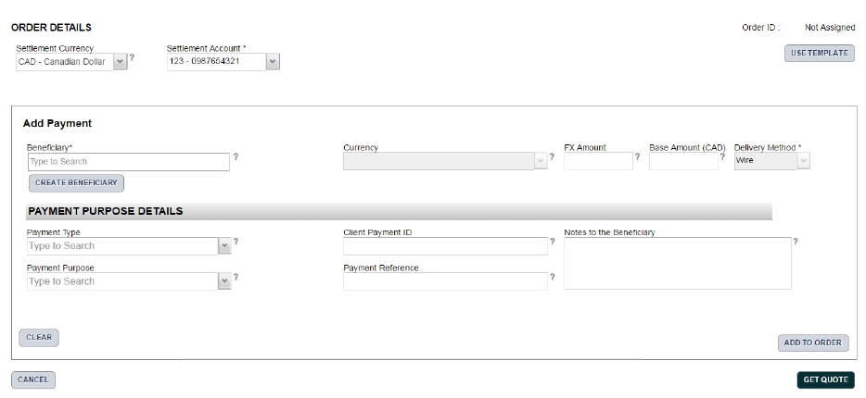

- Editing Beneficiary Screen
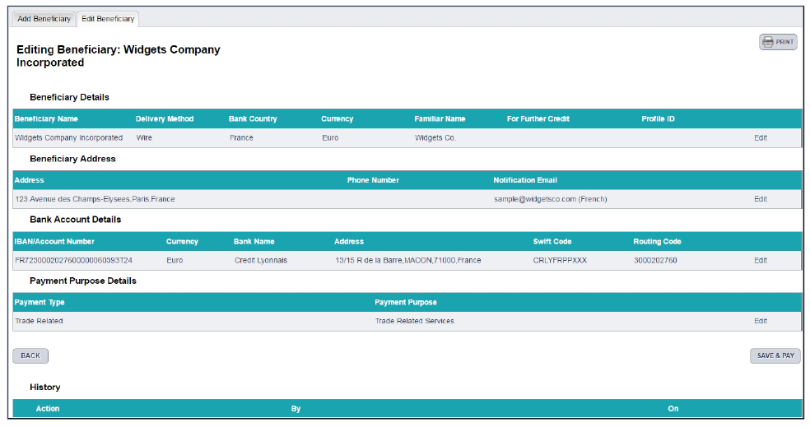
- Payment Details Review
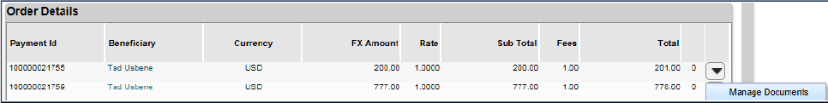

- Print Payment
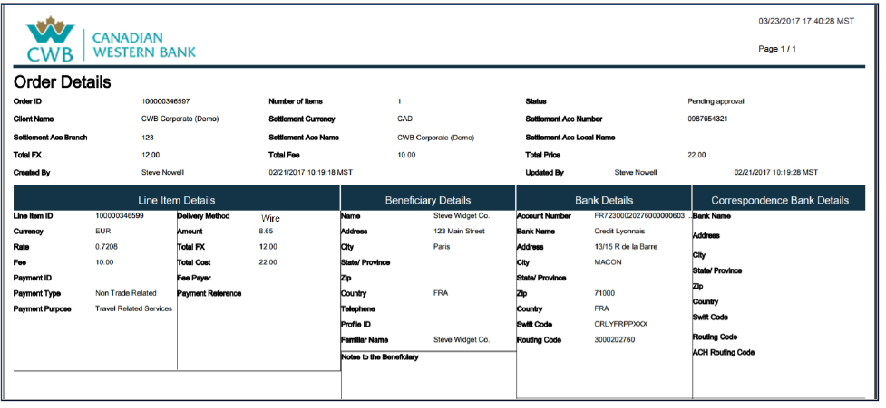
- Quick Quote
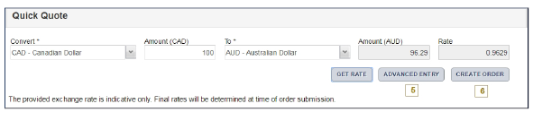

Signature
This section contains the signatures of the primary key stakeholders indicating acknowledgement and acceptance that the information collected in this document represents the interests of all business area stakeholders listed in the Stakeholder section.
Role | Name & Title | Date | Digitally Approved
☐
Add to history that doc was digitally approved
☒
Add to history that doc was digitally approved
☐
Add to history that doc was digitally approved

